**Our Energy Future**

**Future Energy Needs and Consequences from a Physical Sciences Perspective**

*Where are the limits of this problem from a science perspective?*

There are obstacles in the way of meeting 100TW of energy demand in a carbon-neutral way politically, socially, culturally and scientifically. This section has to do with the *scientific* limitations (and possibilities) to solving the problem of meeting energy demand of the future in a manner that does not emit carbon.

A great book is [America's Energy Future](https://www.nap.edu/catalog/12091/americas-energy-future-technology-and-transformation) created by the National Academy of the Sciences in 2009. The below illustration comes from that book, and shows different types of US energy consumption (residential, commercial, industrial and transportation) along with the source of each type of energy consumption in quadrillion BTUs (aka quads).

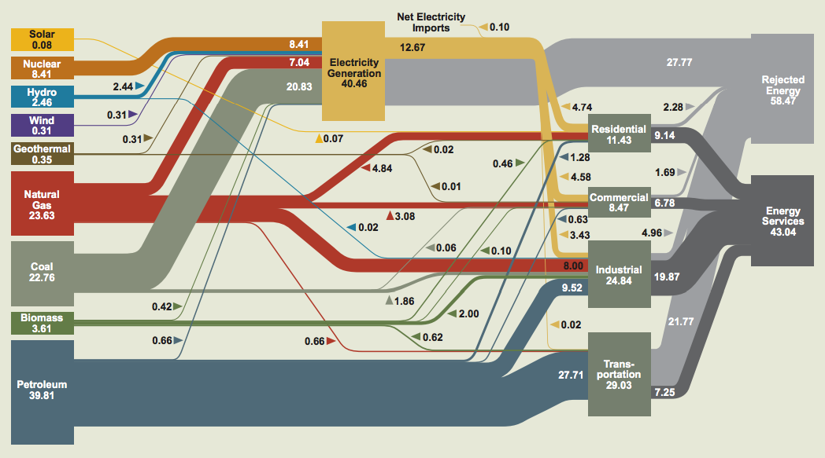

So what do we need to learn about in order to wean ourselves off the finite, carbon-emitting energy sources?

To start answering that question, we often look toward the sun since one hour of sunlight provides enough energy to meet all the demand for all of humanity for a year. The problem is that not only do we need to *capture* that energy, but also to *store* it in a way that provides energy to people on demand.

One way of doing that is my mimicking what the plant does, otherwise known as *artificial photosynthesis*. You want to get rid of the CO2 in the atmosphere by using sunlight, and store it in a form that will be converted into fuel (i.e., plants).

The biggest problem to be solved in artificial photosynthesis is that of catalysts – making the entire process go. It takes a lot of energy to get the energy stored within the plant, and more energy is needed to get it out.

The trick is to be able to discover a process that gets the energy out of the plants in a way that is fast, robust (yields a solid percentage of energy stored in the plant), and energy efficient (yields more energy than what is put into the process).

Because of the sheer amount of energy being received by the sun, a huge emphasis is finding a catalyst that quickly processes the sunlight into something usable (called the catalyst *turnover frequency*). In order for the process to sunlight to convert it to fuel, a photovoltaic cell needs to turn over the sunlight 100,000 times per second.

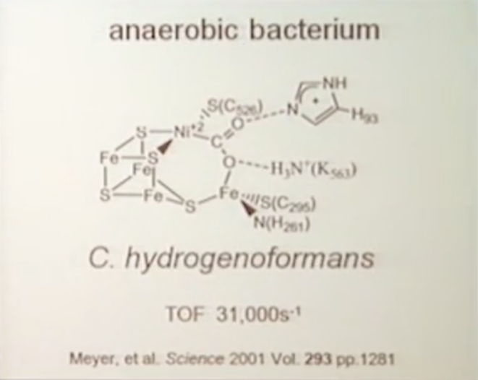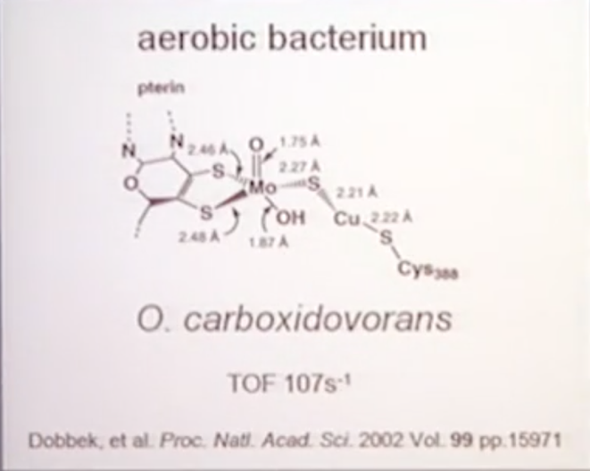Plants use catalysts in photosynthesis to turn sunlight into energy, and a couple of the bacteria they use is below, one aerobic that has an TOF of 107/s, and another anaerobic with a TOF of 31,000/s.

The catalysts are molybdenum (Mo) and iron (Fe), respectively. Finding a catalyst in an artificial environment is extremely difficult (but possible). You have to line up all the electrons of each of the different elements correctly in order to produce a catalyst that quickly yields more energy that is being put into the process.

*What is the status of research in doing this in an artificial photosynthesis?*

Some of the breakthrough research has involved rooting a catalytic metal (tungsten, specifically) onto an electrode which has a TOF of 282/s. This TOF has been sufficient to generate a flow of current which enables splitting CO2 and H2O. The issue is that you need to but too much energy in order to make the catalyst go, and a lot of money and resources are being put into finding the right recipe of catalysts, elements and energy into the process to make it scalable.

The essence of all of this work is to do the following:

*CO2 + H2O + Solar energy O2 = CO + H2*

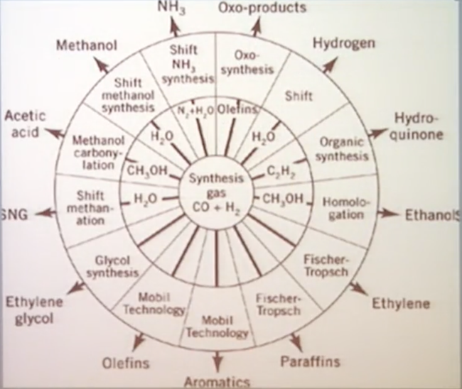CO + H2 is known as synthetic gas, and we can generate a wide array of fuels using this compound. So all of this work revolves around generating synthetic gas.

[**Part 2**](https://www.coursera.org/learn/future-of-energy/lecture/DUUeD/future-energy-needs-and-consequences-from-a-physical-sciences-perspective-part-2)

*Superconductors*

There is experiemental research in the energy sector being carried out in three areas:

* Superconductivity
* Magnetism
* Thermoelectric power generation and cooling

The idea behind superconductors is that if the temperature drops to a certain level, the electrical resistance of a metallic conductor decreases to zero. The implication of this is that an electric current within a superconducting wire can persist indefinitely without any power source.

The discovery of superconductivity occurred in the early 1900s by Heike Kammerlingh Onnes using mercury as the metallic conductor at 451 degrees below zero.

In a normal state, metal conductors consist of a scattering of electons, bouncing off one another. The reason they do this is because there are dynamics like the thermal motion of ions, impurities in the metal, and other electrons going in random directions.

In a superconducting state, electrons no longer move randomly but in concert with one another and the resistance goes away. Electrons pair up (called *cooper pairs*), with one electron moving one way and spinning in a certain direction, while the other electron moves/spins in the opposite direction.

The reason why this is not being widely used is because the temperature where the electrons demonstrate superconductivity needs to be high enough to be practical. However, there has been improvements since the original discovery of superconductivity in the early 1900s.

Various metallic compounds have been shown to have higher critical temperatures than mercury, which is what Onnes used in his original discovery of superconductivity.

The key is to find a metallic compound that has a higher critical temperature than liquid nitrogren (77 Kelvin). There have been some compounds that are approaching 77K but we haven’t reached it yet.

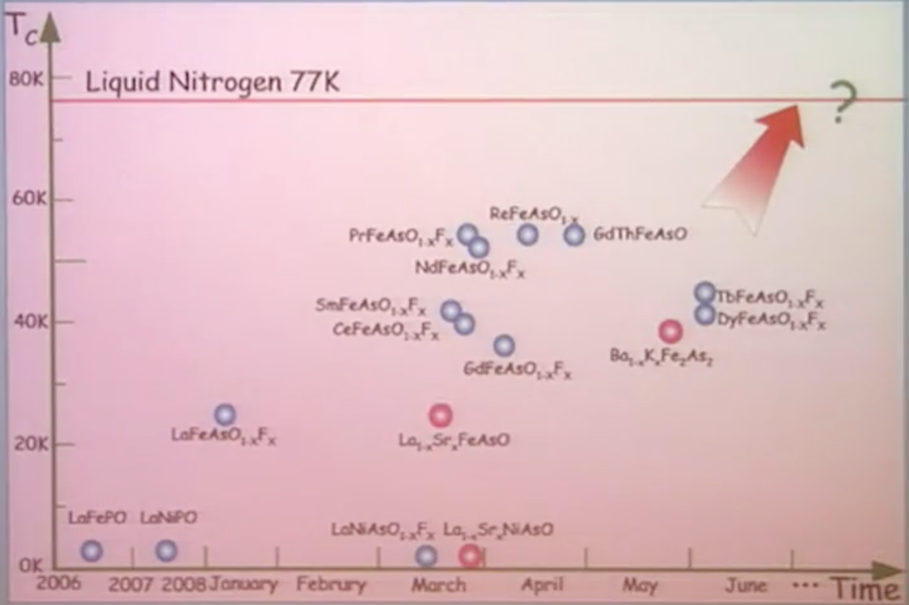The reason why this temperature is such an important threshold is because it is proven that humanity can make wires using liquid nitrogen relatively easily.

The theoretical usage of superconductors are varied and profound. Transportation via levitating trains and ships are one common example, fusion reactors become possible because superconductor wires can keep the plasma cool enough, among other applications. If superconductivity becomes prevalent, it would change the way the world works and interacts with energy.

The great challenge is that humans don’t understand the underlying mechanisms of why superconductivity exists; the fundamental physics isn’t known well enough so it is difficult to make new materials easily.

*Other cutting edge technologies*

* Excitons

Information Technology is approaching a crisis – the circuits included within electronics are generating too much heat, and an extraordinary amount of energy is used to cool down those circuits so the electronics don’t get fried.

There are energy savings to be made if you can make these circuits smaller, more efficient and cooler. The barrier is from a physics perspective, we don’t have a full understanding of what is going on at a nano-level (1 billionth of a meter) to be able to create electronics that use circuits in this more efficient way.

Part of the solution is magnetism – when you put a magnetic field to these circuits within electronics, it results in a giant resistance which gives rise to new properties that can be used for smaller, more efficient materials.

Any telecommunications are transmitted through fiber optics which are comprised of photons. When these photons interact with the circuits within the electronics (comprised of, you guessed it, electrons), it inefficiently transmits energy. Utilizing *excitons* – which are neutral -- in our electronics in place of electrons would provide a major advantage in the amount of energy used in our electronics.

* Plasmons

Another solution that is being researched are *plasmons*, which are essentially parts of a nanomaterial (i.e., extremely, extremely small). Wrangling plasmons effectively could be promising in enhancing the catalytic processes in artificial photosynthesis and solar cells.

* Fusion power

The processes that power stars and the Sun are fusion power, which is only at the point of theory as of today. These fusion processes require fuel and a highly confined environment with high temperature and pressure to create a plasma (fourth state of material apart from solid, liquid and gas). The leading candidate for a practical fusion reactor is the tokamak, which uses powerful magnetic fields to confine the plasma to be able to be used for power generation; it’s imperative to keep the plasma contained otherwise you lose energy.

*Conclusion*

Although the problem of providing energy demand to the world is partly solved by scientific breakthroughs, it is only part of the solution. Once scientific innovations occur, there needs to be the operationalization of the new technology, and ultimately transmission of energy to end users.